REGISTRATIEFORMULIER MASTERPROEF 2020 – 2021

MASTER’S THESIS REGISTRATION FORM 2020 – 2021

In te dienen via Canvas vóór 31 oktober 2020

To be submitted via Canvas before 31th of October 2020

Voornaam:  
First name: Oguz

Familienaam:  
Surname: Gelal

Rolnummer:  
Enrolment number: 0534627

Opleiding:  
Program:

* Master of Science in de Ingenieurswetenschappen: Computerwetenschappen

Master of Science in Applied Sciences and Engineering: Computer Science

* Master of Science in de Toegepaste Informatica

Voorlopige titel:  
Provisional title: Intertext – The Everything App

Onderwerp:  
Subject:

A family of front-end applications that can interpret Intertext UIDL (User Interface Description Language), and generate appropriate front-ends for the host platform.

Promotor: Prof. Dr. Beat Signer

Directe begeleider:  
Direct supervisor: Prof. Dr. Beat Signer

Datum, naam en handtekening student:  
Date, name and signature of the student:  
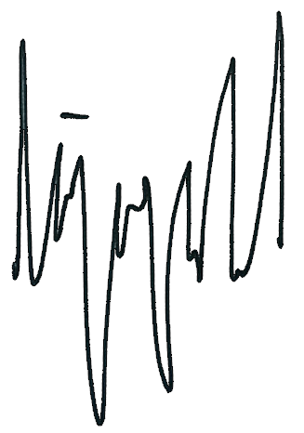  
07/10/2020

Datum, naam en handtekening promotor:  
Date, name and signature of the promotor: 07.10.2020, Beat Signer